ASSIGNMENT # 07

**Heat Pump**

**EXPERIMENT # 6:**

**Observe The Temperature And Pressure Limits**

**Corresponding To Specifically**

**Evaporator And Condenser In HEAT PUMP**

**Introduction:**

* A **Heat pump** is a device that transfers heat energy from a source of heat to what is called a [thermal reservoir](https://en.wikipedia.org/wiki/Thermal_reservoir).

**Main Parts:**

 The most common design of a heat pump involves four main components;

* a [condenser](https://en.wikipedia.org/wiki/Condenser_(heat_transfer)),
* an [expansion valve](https://en.wikipedia.org/wiki/Thermal_expansion_valve),
* an [evaporator](https://en.wikipedia.org/wiki/Evaporator)
* a [compressor](https://en.wikipedia.org/wiki/Compressor).

The heat transfer medium circulated through these components is called [refrigerant](https://en.wikipedia.org/wiki/Refrigerant).

**Principle:**

“Its operating **principle** is based on compression and expansion of a working fluid, or so called 'refrigerant'. A **heat pump** has four main components: evaporator, compressor, condenser and expansion device. ... In the condenser this **heat** is delivered to the consumer at a higher temperature level.”

**Diagram: ( heat pump)**  
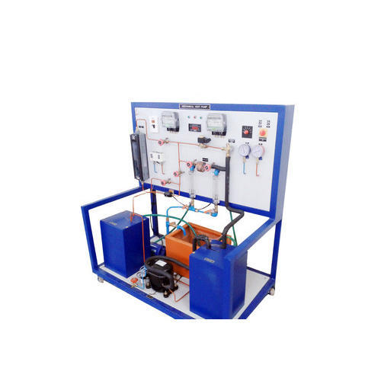

**Working of Heat Pump Trainer:**

* **Heat pumps** move thermal energy in the opposite direction of spontaneous **heat** transfer, by absorbing **heat** from a cold space and releasing it to a warmer one. A **heat pump** uses external power to accomplish the work of transferring energy from the **heat** source to the **heat** sink.

**Heat Pump in Summer:**

* During the **summer**, **heat pumps** work just like regular air conditioners. ... During the condensation process, the liquid refrigerant gives up its **heat**, which is radiated to the outside air. Now a cold, pressurized liquid, the refrigerant moves into the expansion valve, which restricts the flow of the liquid.

**Heat Pump in Winter:**

* During the **winter**, **heat pumps** operate like an air conditioner in reverse. The refrigerant absorbs **heat** from the air outside and uses it to warm your home. ... In fact, most **heat pumps** can efficiently absorb **heat** from the air outside down to as cold as 20 degrees or lower!

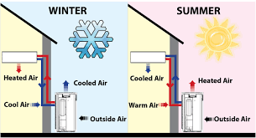

**What temperature is a heat pump not effective?**

* **Heat** pumps don't work well below 25-30 degrees Fahrenheit. But what you might **not** know is that the **heat pump temperature** range is broader than most people think, and with the addition of supplemental **heating** it can work even in the chilliest of **temperatures**.

**Will a heat pump work below zero?**

* The short answer is yes, a **heat pump** **will work** in cold weather. But **heat pumps** only **work** efficiently if they have a backup **heat** source, like a gas furnace or electrical resistance coils.

**The Heating cycle of a heat pump: Figure # 7-1:**

* 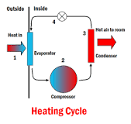It works by taking **heat** in from air outside, warming it up further, and using this warm air to **heat** indoor air. It does so by the following process: Liquid refrigerant absorbs **heat** in the "evaporator" from the outdoor air, turning into a gas as shown in

Figure # 7-1.

**The cooling cycle of a heat pump:**

* 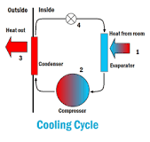 It is used to cool a space by removing **Figure # 7-2:**

**Heat** from it and expelling it to another area, usually to the outdoors for **air conditioning** or to the room for a refrigerator. ... The cold refrigerant absorbs **heat** from the hotter room in the evaporator, so the room will cool down as shown in figure # 7-2.

**Efficiency of Heat Pump:**

* An Air Source **Heat Pump** (ASHP) will typically produce around 3kW thermal energy for every 1kW of electrical energy consumed, giving an effective “**efficiency**” of 300%. It is thermodynamically impossible to have an **efficiency** of more than 100%, as this implies that more energy is being produced than is being put in.

**Applications of Heat Pump:**

* Domestic hot water ,Space Heating ,Cooling for Bungalows ,Apartments, Farm House and Villas
* Sanitary hot water for Hotels ,Hospitals , Leisure center
* Commercial heating and cooling or Buildings ,Complexes
* Constant hot water for swimming pool
* Constant temperature for green house
* High temperature heat pumps for drying and Steaming

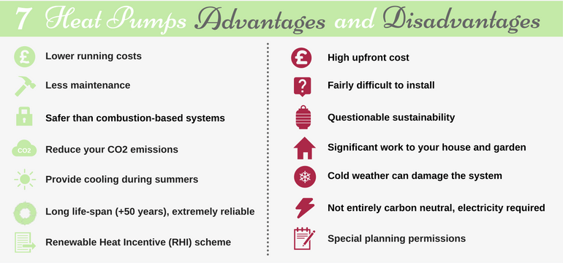

**Co-efficient of Performance:**

* The **coefficient of performance** or **COP** (sometimes **CP** or **COP**) of a [heat pump, refrigerator or air conditioning system](https://en.wikipedia.org/wiki/Heat_pump_and_refrigeration_cycle) is a ratio of useful heating or cooling provided to work required. Higher COPs equate to lower operating costs. The COP usually exceeds 1, especially in heat pumps, because, instead of just converting work to heat (which, if 100% efficient, would be a COP of 1), it pumps additional heat from a heat source to where the heat is required.
* For complete systems, COP calculations should include energy consumption of all power consuming auxiliaries. COP is highly dependent on operating conditions, especially absolute temperature and relative temperature between sink and system, and is often graphed or averaged against expected conditions.

**Relation of COP between Heat pump and Refrigerator:**

The COP of **Refrigerator** is given by the following equation:

**COP** = Desired Output/Required Input=Cooling Effect/Work Input = QL/Win.

The **COP** of a **Heat pump** is given by the following equation:

**COP** = Desired **Output/Required** Input =**Heating** Effect/Work Input = QH/Win.

* Both the **COP** of a **refrigerator** and a **heat pump** can be greater than one.

**QL +Win=QH**

**Divide by Win on both sides:**

**QL/Win +Win/Win =QH/Win**

**COP (REF) +1=COP (HP)**

* Hence ,**COP** of Heat Pump is Greater than COP of Refrigerator.

**Calculations:**

**For Summer Season :**

|  |  |
| --- | --- |
| **Part Name** | **Value** |
| Compressor Outlet | 34.2 |
| Condenser Inlet | 22.4 |
| Condenser Mid | 20.5 |
| Condenser Outlet | 20.7 |
| Expansion Valve | -8.0 |
| Liquid Receiver | 20.4 |
| Evaporator Inlet | -10.5 |
| Evaporator Mid | 18.2 |
| Evaporator Outlet | 17.6 |
| Compressor Inlet | 20.6 |

**For Winter Season:**

|  |  |
| --- | --- |
| **Part Name** | **Value** |
| Compressor Outlet | 36.6 |
| Condenser Inlet | 23 |
| Condenser Mid | 19.2 |
| Condenser Outlet | 18.7 |
| Liquid Receiver | 17.2 |
| Expansion Valve | -8.9 |
| Evaporator Inlet | -12.2 |
| Evaporator Mid | 12 |
| Evaporator Outlet | 13.6 |
| Compressor Inlet | 14.4 |

**Graphical Representation:**

**PV Diagram:**

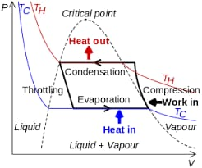

**TS Diagram:**

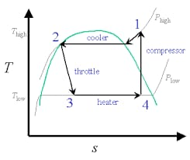

***“THANK YOU TEACHER FOR HELPING ME BLOOM”***